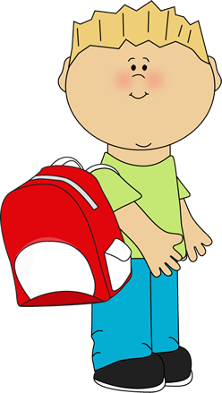
First Grade School Supply List

The following is a list of school supplies your child will need this year:
- 1 pack of wide-ruled loose leaf white paper
- 1 school supply zipper pouch (NO PENCIL BOXES) with the following:
  - 1 box of crayons (maximum of 16)
  - 5 sharpened pencils daily (NO mechanical pencils allowed)
  - 1 pair of FISKARS brand scissors
  - 1 glue stick
  - 1 bottle of white school glue
  - 1 large pink eraser
  - DO NOT BRING SHARPENERS TO CLASS
- 2 folders with pockets
- 1 backpack (NO ROLLING BACKPACKS PLEASE)
- 6 black and white composition notebooks
- 1 pack of Dry-erase markers
- 1 highlighter
- 2 reams of 8 1/2 by 11 copy paper
- 1 pack of index cards
- headphones

Classroom Wish List:
- 2 containers of Clorox wipes
- 1 family sized box of tissues
- 1 container of anti-bacterial hand sanitizer
- 1 pack of white card stock paper

Please check periodically during the year to replenish needed items. Make sure all supplies are labeled with your child’s name.

